Title Page
Personal Exposure to PM_{2.5} in Chinese rural households in the Yangtze River Delta

R. L. Hu^{1, 2}, S. X. Wang^{1, 2,} *, K. Aunan³, M. J. Zhao^{1, 2}, L. Chen⁴, Z. H. Liu⁴, M. H. Hansen⁵
¹State Key Joint Laboratory of Environment Simulation and Pollution Control, School of Environment, Tsinghua University, Beijing 100084, China
²State Environmental Protection Key Laboratory of Sources and Control of Air Pollution Complex, Beijing 100084, China
³Center for International Climate Research (CICERO), P.O. Box 1129 Blindern, N-0318 Oslo, Norway
⁴College of Environmental & Resource Science, Zhejiang University, Zhejiang 310058, China
⁵Department of Culture Studies and Oriental Languages, University of Oslo, Norway
*S. X. Wang
State Key Joint Laboratory of Environment Simulation and Pollution Control, School of Environment, Tsinghua University, Beijing 100084, China.
E-mail: shxwang@tsinghua.edu.cn

Abstract
High levels of PM_{2.5} exposure and associated health risks are of great concern in rural China. For this study, we used portable PM_{2.5} monitors for monitoring concentrations online, recorded personal time-activity patterns, and analyzed the contribution from different microenvironments in one rural area of the Yangtze River Delta, China. The daily exposure levels of rural participants were 66μg/m³ (SD 40) in winter and 65μg/m³ (SD 16) in summer. Indoor exposure levels were usually higher than outdoor levels. The exposure levels during cooking in rural kitchens were 140μg/m³ (SD 116) in winter and 121μg/m³ (SD 70) in summer, the highest in all microenvironments. Winter and summer values were 252μg/m³ (SD 103) and 204μg/m³ (SD 105), respectively, for rural people using biomass for fuel, much higher than those for rural people using LPG and electricity. By combining PM_{2.5} concentrations and time spent in different microenvironments, we found that 92% (winter) and 85% (summer) of personal exposure to PM_{2.5} in rural areas was attributable to indoor microenvironments, of which kitchens accounted for 24% and 27%, respectively. Consequently, more effective policies and measures are needed to replace biomass fuel with LPG or electricity, which would benefit the health of the rural population in China.

Key words: Personal exposure assessment; Household air pollution; Rural areas; China; PM_{2.5}; Biomass stoves.

Practical implications: Our study suggests that many rural people in China are faced with a high level of PM_{2.5} exposure, especially in indoor microenvironments and when cooking with biomass stoves. Though there have been many policies and measures for controlling ambient and indoor air pollution in China, more effort is needed to reduce traditional household solid fuel use to help improve the quality of life of people in rural China.

Text

Introduction
Fine particulate air pollution is of worldwide concern and remains ubiquitous and a major cause of ill health in many regions (1, 2)(Lim, 2012, Steinle, 2015). Research shows that human cardiovascular and respiratory diseases are closely related to PM_{2.5} exposure (3-7) and may cause significant economic losses to society (8). In 2017 the population of rural China reached 577 million, constituting 41% of the country’s total population. About 61.1% of rural households mainly use solid fuels (wood, crop residue, and coal) for cooking and 40.4% use them for heating (9). These fuels have low burning efficiency, and their use results in heavy household air pollution (10-15). This especially affects women, who do the majority of cooking in most households (16-18). A growing body of evidence suggests that high daily average PM_{2.5} concentrations in homes using household solid fuel, reaching up to about 2000μg/m³ in the kitchen (11, 19), are determined by the properties of the fuel used, stove type used, cooking style, house ventilation, geographical area, and season (11, 16, 17, 20-32). Other activities may also lead to greater PM_{2.5} exposure and ill health effects for rural people (33, 34), for example, smoking (26, 35, 36). In addition, ambient air quality is also affected by the emission of gaseous precursors of secondary particles from household solid fuel use (37, 38). In general, data on personal exposure to PM_{2.5}, especially in indoor microenvironments where people spend large amounts of time (39-42), is a better indicator of the dose inhaled and may help improve health impact assessments (3, 43-45), thereby warranting measurements in rural China.
However, indoor and neighborhood ambient PM_{2.5} concentration levels for rural populations are not measured routinely in China. Studies focusing on personal exposure to PM_{2.5} are usually conducted in urban areas or large cities, showing, for example, that in Beijing, PM_{2.5} exposure in homes accounts for 40–69% of total exposure (46), and that indoor air is an important factor affecting human health, especially when ventilation is poor and in winter (41). Several studies of rural China have used Teflon filters for long-term sampling with fixed-site or portable monitors, providing data on an integrated measurement of exposure levels for participants (16, 17, 19, 26-28, 30, 35, 47). Such studies are inadequate for elucidating the characteristics of rural personal PM_{2.5} exposure in different microenvironments and are not ideally suited for measuring peak exposures, since personal activity pattern is a source of unexplained variability when comparing personal PM_{2.5} exposure (40, 42, 48-50). A few studies have used low-cost, lightweight, portable online instruments to measure particle concentration or personal exposure (2, 20, 31, 36), but such monitors are still rarely used in rural China. A study of Guizhou used portable monitors to determine the daily PM_{2.5} concentration levels in a range of kitchens using different fuels (20), but as the time-activity pattern was not measured, the study did not identify the exposure concentration during cooking. Generally speaking, quantification of personal exposure by combining PM_{2.5} exposure concentration in different microenvironments and time-activity patterns has not taken place in studies of rural China. Moreover, there are knowledge gaps regarding how demographic factors (e.g., gender and age) and smoking behavior affect personal PM_{2.5} exposure levels of rural people. In addition, little research has addressed the differences between rural and urban areas or the causes of these differences.
In the current study, we utilize the opportunities provided by the recent availability of portable online PM_{2.5} monitors to evaluate the characteristics of personal exposure to PM_{2.5} in rural areas in the Yangtze River Delta of China. This is a study within the broader, interdisciplinary Airborne project, dedicated to research on the interface of air pollution, science, policy making, and population in China (51). We depict how fuel use and factors such as gender, age, and smoking behavior affect daily average personal PM_{2.5} exposure levels. Then we address existing knowledge gaps regarding personal exposure levels in different microenvironments based on readings from portable PM_{2.5} monitors and time-activity pattern records, and further investigate the exposure level in kitchens when cooking is taking place with different fuel types or stoves. In addition, we analyze how different microenvironments affect the daily exposure amounts of rural people. Furthermore, we compare the rural exposure patterns to those of a neighboring urban setting. The results of this study are significant for air pollution exposure reduction, and encourage actions that reduce the risk of PM_{2.5} exposure and associated health damage in rural China.

Methods

Study area
Our study was carried out in Quzhou, located in western Zhejiang Province, which is in the southern part of the Yangtze River Delta and China’s largest economic zone (see Figure S1). The two rural sites in this study, Wangjiafan and Jianchencun, are located 12–15 kilometers southwest of Quzhou’s city center (see Figure S2). According to data collected by members of our larger research group, many families in the two villages owned both a traditional biomass stove and a clean stove, like liquid petroleum gas (LPG) or electric, but preferred to use their biomass stove for economic, convenience and cultural reasons. Most of them were not aware of the risks of household air pollution (52). The neighboring urban site we studied was Fangmenjie, an inner city street.

PM_{2.5} measurements
The measurement campaign was carried out during three periods, August 29–September 10, 2015 (P1, summer), January 7–21, 2016 (P2, winter) and January 7–20, 2017 (P3, winter). The sampling in the two rural sites was carried out during all three periods. To obtain exposure information about the urban population, experiments were also designed in the urban sites in P1 and P2, but with a smaller sample size. The study participants were recruited randomly in both rural and urban sites. Personal PM_{2.5} exposure levels were monitored using the UCB Particle and Temperature Sensor (PATS+), a newly updated portable PM_{2.5} monitor developed by Berkeley Air Monitoring Group and used in many previous studies (20, 31, 36, 53). The PATS+ is a small, lightweight, portable data logging device that uses an optical scattering sensor to measure real-time PM_{2.5} particle concentration and was originally designed for measuring PM_{2.5} in indoor environments where solid fuels were used, but can be used for outdoor monitoring as well. It can run for >80 hours of uninterrupted sampling on an internal, rechargeable battery, and for several weeks when attached to an external battery. The logging interval is 2s to 1h, and the detection limits are 10 to 20 μg/m³ (lower) and 30 to 50 mg/m³ (higher). To collect consecutive data on the 24h personal exposure level, a PATS+ monitor was fixed on the upper arm of the participants and kept beside their beds when they were sleeping. During monitoring, the PATS+ monitors were set to record PM_{2.5} concentration every 10 seconds. At the end of each sampling, the data were exported to a computer and the instruments were inspected, carefully cleaned, and recharged.
All the PATS+ monitors used in the measurements were calibrated for biomass particles in the lab by Berkeley Air Monitoring Group before they were put to use. In order to test the performance of the PATS+ monitors, the ambient PM_{2.5} was monitored by the PATS+ monitors and the local Environmental Protection Board (EPB) in Quzhou synchronously for one or two days before every experiment period. The hourly average data are plotted in Figure S3. To further ensure the accuracy of the PATS+ monitors during P3, when we expanded the measurement campaign, the measurement of ambient PM_{2.5} in the rural villages (where there were no official monitoring stations) was carried out in January 2017, during which time PATS+ monitors were also placed outdoors. In each village, PATS+ monitors were placed 2–3m above the ground in the central square of the village, at the outskirts of the village, and at two locations in between (i.e., four locations in each village). Filter sampling was carried out by using a BAM 1020 Beta Attenuation Mass Monitor (Met One Instruments, Inc., USA) set at one outdoor location during the outdoor measurement period. The Teflon filter in the Met One Instrument was replaced every 23.5 hours and weighed before and after the monitoring. The volume was also recorded. To weigh the filters, they were first placed in a balance room with a constant temperature and humidity for 24 hours, statically discharged by using a polonium source and then weighed by using an analytical balance with the precision of 1μg. Each filter was weighed at least twice to ensure the difference between the two measurements was less than 4μg. As Figure S4 shows, the daily average concentration calculated from all PATS+ sampling was consistent with that from the filter sampling. The Pearson correlation coefficient of the hourly calibration reached 0.87 and that of the 24h gravimetric calibration reached 0.95, which indicates an acceptable accuracy in the PATS+ data.
A questionnaire was completed by each study participant. It included questions about age, gender, education level, literacy, smoking behavior, whether or not they were the main cook in the household, dwelling characteristics, fuel used, and stove type used. In addition, the participants filled in a time-activity pattern diagram indicating the time intervals they were located in each of six different microenvironments (kitchen, living room, bedroom, traffic, other indoor, which included residential, office, etc., and outdoor) during the 24h monitoring period. Longer interviews and informal conversations with more than one hundred residents were carried out by other members of the larger research team and they help inform the results reported in this article.
The personal exposure concentrations of PM_{2.5}, personal information, time-activity pattern, and exposure amounts of the participants were analyzed using SPSS and Excel software. The daily average exposure concentration of each participant was derived from the 24h PM_{2.5} concentrations as measured by the PATS+ monitor on the participant’s upper arm. Then the daily average of PM_{2.5} exposure levels in the different seasons and for different demographic groups (age, gender, smoking behavior, and stove use) were calculated, and the estimates for the rural and urban samples were compared. We also calculated the PM_{2.5} exposure concentration of the participants in different microenvironments based on time-activity pattern records and time-resolved PM_{2.5} data in these microenvironments. Finally, the contribution to the total daily PM_{2.5} exposure amount from the exposure amount in various microenvironments was estimated. The exposure amount was calculated by using equations (1) and (2). All the arithmetic mean values, standard deviations (SD), 95% confidence intervals (95% CI) and significance levels (p value) were calculated and are shown in Tables S1–S7. Propagation of error in calculations has been taken into account. The difference between various groups in the present study discussed below were tested using the independent-samples T test.
(1)
(2)
E: Average daily exposure amount
E_{i}: Average exposure amount in microenvironment i
t_{i}: Average time spent in microenvironment i
C_{i}: Average PM_{2.5} concentration level in microenvironment i
i: kitchen, living room, bedroom, traffic, other indoor, or outdoor

Participants
Participant information is shown in Table 1. A total of 78 valid samples of personal PM_{2.5} exposure levels were collected, 57 from rural areas and 21 from urban areas. Over the course of the three study periods, 57 personal samples were collected in winter and 21 in summer. Of the rural participants, females, who usually cooked for their families, accounted for 70% of the participants. The education level was generally lower among the rural participants than among the urban ones. About 90% of the rural participants had elementary education or less. Table 1 also shows the main types of household fuel that participants in rural areas used (LPG, electricity, or biomass). In contrast, clean energy, LPG or electricity, was used for cooking in all the urban households.
The age distribution in Figure S5 indicates that the average age of the participants was about 50–60, and the members of rural households were generally older than those of urban households. It reflects wider trends in rural China that the majority of rural young people leave their hometown to work or attend school and mostly the middle aged and elderly stay at home in rural areas (54).

Table 1 Participant information
Period |  | Summer (Aug–Sep 2015) |  |  | Winter (Jan 2016 & Jan 2017)
Area |  | rural | urban | total | rural | urban | total
# of Households |  | 12 | 9 | 21 | 45 | 12 | 57
Gender | Male | 2 | 3 | 5 | 15 | 4 | 19
 | Female | 10 | 6 | 16 | 30 | 8 | 38
Education level* | Level 1 | 12 | 1 | 13 | 39 | 1 | 40
 | Level 2 | 0 | 4 | 4 | 6 | 6 | 12
 | Level 3 | 0 | 4 | 4 | 0 | 5 | 5
Stove type | LPG | 6 | 8 | 14 | 24 | 10 | 34
 | Electric | 1 | 1 | 2 | 1 | 2 | 3
 | Biomass | 5 | 0 | 5 | 20 | 0 | 20
*Level 1: illiterate or primary school, Level 2: middle or high school, Level 3: college or higher

Results and Discussion

Daily average personal PM_{2.5} exposure levels
Table S1 and Figure 1 summarize the daily average PM_{2.5} exposure levels of the 78 participants grouped by season and location. Figure 2 shows the difference between females and males, and it also includes the average rural and urban ambient PM_{2.5} concentration levels monitored by the local EPB in Quzhou during the relevant time periods. To obtain the figures shown for the rural ambient level, we used data from the urban monitoring stations closest to the villages. We did not observe a significant difference between the rural ambient PM_{2.5} concentration level in P2 and that in P3 (see Figure S6), thus we aggregated them. There was no pronounced difference between the daily average PM_{2.5} exposure levels in winter (66μg/m³ [SD 40]) and summer (65μg/m³ [SD 16]) among the rural participants as a group. However, they were both significantly higher than the mean rural ambient PM_{2.5} concentrations (40μg/m³ [SD 18] in winter/39μg/m³ [SD 2] in summer) and the daily WHO air quality limit guideline of 25μg/m³, indicating serious indoor air pollution.
In rural areas, the daily winter exposure level of females (71μg/m³ [SD 44]) was significantly higher than that of males (55μg/m³ [SD 28]) (p=0.082). This is probably because 96.7% of the rural female participants cooked and 50.0% of them mainly used biomass stoves for cooking during monitoring. Comparatively, only 73.3% of the rural male participants cooked and 33.3% used biomass stoves. It should be noted that cooking with biomass stoves led to high levels of PM_{2.5} exposure, which will be discussed in a later section. The situation was different in summer, when the daily exposure level of females (61μg/m³ [SD 13]) was lower than that of males (83μg/m³ [SD 17]), but not significantly so (p=0.207). That might be because there were only two rural male participants in the summer period, both 70 years old. They used biomass for cooking, and one of them was exposed to environmental tobacco during the monitoring. The sample size of rural males was too small to verify the comparative results.
When comparing rural and urban areas, the daily winter exposure level of females in rural areas (71μg/m³ [SD 44]) was slightly higher than that for both urban females (49μg/m³ [SD 46]) (p=0.134) and males (50μg/m³ [SD 33]) (p=0.189), which were similar. This might be because urban participants, whether male or female, cooked with similar frequency and all used LPG or electric stoves. We observed a higher ambient concentration of PM_{2.5} in urban areas (47μg/m³ [SD 26] in winter/54μg/m³ [SD 17] in summer) than in rural areas, which might increase the exposure to fine particles for urban people.

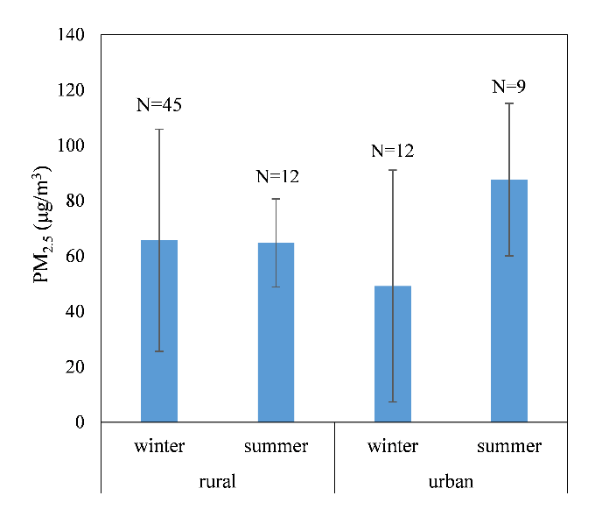
Fig. 1 Daily average exposure levels of all participants (For this and all subsequent figures, N = Sub-group sample sizes. Error bars represent the standard deviations.)

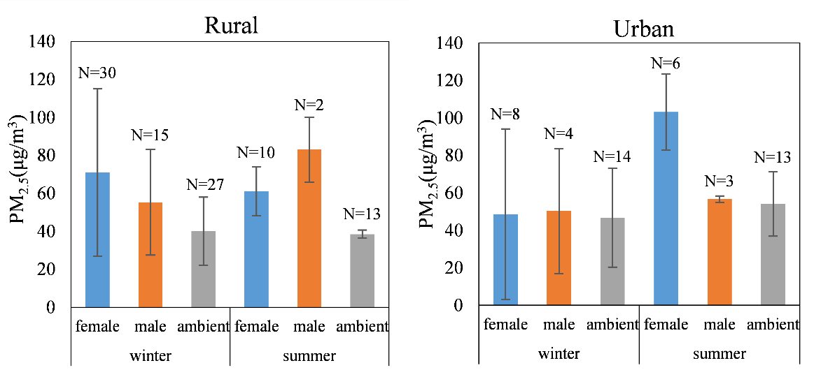
Fig. 2 Daily average exposure levels of the participants grouped by gender and season in rural and urban areas

Figure 3 displays the daily average PM_{2.5} exposure levels of different age groups in rural and urban areas in both seasons. In winter, females 50–69 years old were exposed to a PM_{2.5} concentration of 83μg/m³ (SD 51), higher than the levels those who were over 70 years old and those who were under 50 years old were exposed to, 57μg/m³ (SD 18) (p=0.038) and 45μg/m³ (SD 19) (p=0.019), respectively. A possible explanation for this could be that the latter were not exposed to tobacco smoke and, importantly, 75% of females under 50 used LPG for cooking in this study. Meanwhile, of females 50–69, 33.3% were living with a family member who smoked daily. However, we observed no significant difference between males 50–69 years old (54μg/m³ [SD 25]) and those over 70 (57μg/m³ [SD 31]) (p=0.899), since the percentage of people cooking with biomass during monitoring was the same among males 50–69 and those over 70, 33.3%. The trend was similar for females 50–69 and 70+ in summer, for which the daily exposure levels were 60μg/m³ (SD 14) and 63μg/m³ (SD 9), respectively (p=0.719). Although 57.1% of females 50–69 in the summer sample were passive smokers, only 28.6% of them used biomass for cooking. Consequently, despite the small number of participants, we can conclude that the lifestyle of people who were under 50 contribute to a reduction in PM_{2.5} exposure. Older people were more likely to use solid fuel for cooking, and rural females 50–69 years old were more likely to be exposed to tobacco, both factors that increased the PM_{2.5} exposure level.
Regarding the different exposure levels among age groups, however, our results deviated somewhat from those of a study conducted in Lijiang, Yunnan (16), which showed that the daily exposure levels for women aged 25–49 (122μg/m³), 50–69 (120μg/m³) and 70+ (95μg/m³) were all higher than in our study. This may be related to different lifestyles in different locations, including the type of stove used, the degree of ventilation in kitchens, and cooking frequency. But Baumgartner et al.’s research (year?) also found a narrower exposure gap between younger and older women during summer, which they attributed to the fact that the younger women did most of the cooking in winter when agricultural work was limited while older women cooked more in summer when younger women were working outside.
As for urban areas, the overall daily average personal exposure level for both females and males who were 50–69 years old (62μg/m³ [SD 49] in winter/100μg/m³ [SD 28] in summer) was also higher than those of participants who were under 50 (35μg/m³ [SD 15] in winter/73μg/m³ [SD 18] in summer). The reason for this is that younger urban people who are employed are likely to spend less time on cooking than the older generation. On the other hand, higher urban ambient particle concentrations in summer contributed to higher personal exposure levels. However, we did not expect that the winter concentration levels of the urban females 70+ and the two males under 50 would be as low as they were. Presumably this was because they spent significant amounts of time in indoor microenvironments (the former retired at home and the two males in their offices) where the PM_{2.5} concentration levels were relatively low. (This is discussed in more detail in the following section.)

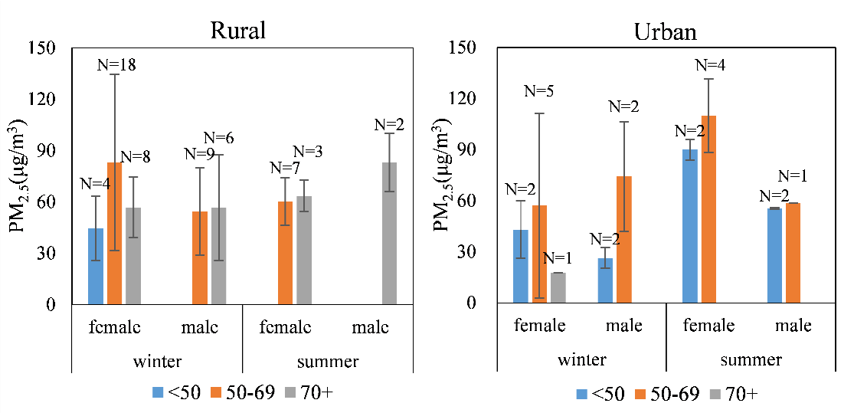
Fig. 3 Daily average exposure levels of different age groups in rural and urban areas

The type of stove that was used for cooking had a significant impact on the daily average PM_{2.5} exposure levels of the rural population (see Table S2 and Figure 4). The exposure concentration of people who mainly used electric stoves for cooking was the lowest, about 32μg/m³ (SD 5). People who used LPG and biomass stoves were exposed to a PM_{2.5} level of 58μg/m³ (SD 31) and 77μg/m³ (SD 33), respectively. Clearly, the use of biomass fuel increased the level of exposure to PM_{2.5}, whereas the use of electricity was associated with a lower exposure level and thus less harmful for people’s health. These results are consistent with the Lijiang study (16), which found that the individual daily PM_{2.5} exposure concentration when LPG and electric stoves were used was 91μg/m³, but when biomass fuel was used, it was 119μg/m³. Other studies (17-19, 25, 47) have also found that using biomass fuel for cooking increased PM_{2.5} concentrations and that the use of cleaner fuels like natural gas and electricity did less harm to human health (55).
Figure 5 shows the rural PM_{2.5} exposure levels of smokers, passive smokers, and people who were not exposed to tobacco smoke (also listed in Table S3). After excluding the interference of the high PM_{2.5} concentration in kitchens (only households where LPG was the main cooking fuel during monitoring were analyzed here), the results reveal that the daily average PM_{2.5} exposure levels of smokers and passive smokers were about 61μg/m³ (SD 7) and 62μg/m³ (SD 31), respectively, both somewhat higher than that of non-smokers, which was 48μg/m³ (SD 27) (p=0.130 and p=0.128, respectively). This is consistent with previous studies (20, 56). The variance of levels of personal exposure among smokers was smaller, stemming from the fact that the sample included only a few smokers, which might have affected the result. People who were not exposed to tobacco smoke in their daily lives were less likely to be affected by PM_{2.5}.

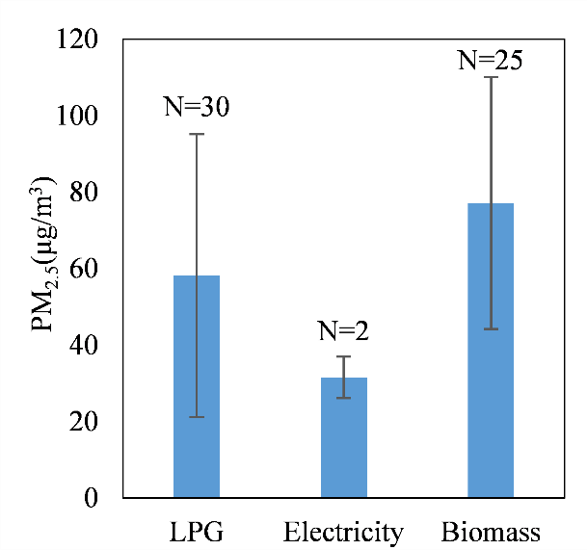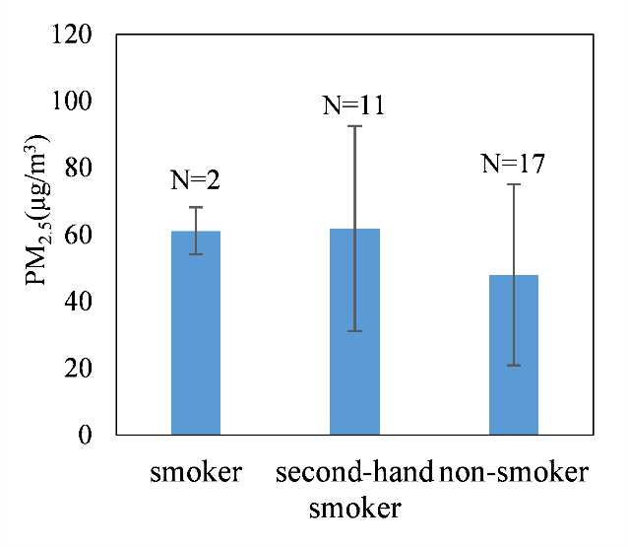

Fig. 4 Daily average exposure levels of rural participants by stove type
Fig. 5 Daily average exposure levels of rural participants by exposure to smoking

Personal exposure in different microenvironments
The PM_{2.5} exposure concentration in different microenvironments in rural and urban areas is listed in Table S4 and shown in Figure 6. The statistical result reflects that, in the six microenvironments, the PM_{2.5} exposure level was the highest in kitchens where cooking took place in both seasons for rural participants, on average 140μg/m³ (SD 116) in winter and 121μg/m³ (SD 70) in summer (the large standard deviation was due to the difference in the types of stoves in the kitchens being monitored). The exposure level was the lowest in bedrooms, 43μg/m³ (SD 41) in winter and 49μg/m³ (SD 18) in summer. The exposure levels in living rooms and other indoor microenvironments away from home were slightly higher than those in bedrooms and outdoors in winter, while in summer, the level in living rooms was a bit lower than outdoors, which can be attributed to better indoor ventilation and more human activity taking place outdoors in summer.
In urban areas, outdoor activities and being in traffic were associated with higher exposure levels than indoor microenvironments except for kitchens, where the personal exposure level was also the highest, which is consistent with previous studies (46, 49, 57). However, the exposure level in other indoor microenvironments was the lowest of all microenvironments, 26μg/m³ (SD 12) in winter and 42μg/m³ (SD 16) in summer. That could be due to indoor microenvironments such as offices and other workplaces being less pervious to outdoor air pollution than residences included in our sample.
Comparing the results of rural and urban areas, we found that the winter exposure levels of rural people in kitchens, living rooms and other indoor rooms were higher than those of urban people. In summer, however, the exposure level of rural people was higher than that of urban people only in other indoor microenvironments. Thus, different from urban areas where outdoor air pollution is more serious, PM_{2.5} exposure in indoor microenvironments is of particular concern in rural areas, especially in winter when house ventilation is limited in order to keep out the cold.
Figure 7 and Table S5 present the rural average levels of PM_{2.5} exposure when cooking in kitchens by stove type. In winter, the exposure level in kitchens where biomass fuel was used was on average 252μg/m³ (SD 103), much higher than in kitchens where LPG (59μg/m³ [SD 26]) (p=0.000) and electric stoves (52μg/m³) were used. A similar pattern was observed in summer: 204μg/m³ (SD 105) in kitchens where biomass fuel was used versus 78μg/m³ (SD 20) where LPG stoves were used (p=0.037) and 47μg/m³ where electric stoves were used. While there was only one household where an electric stove was used in each season, our measurements indicated that people using electric and LPG stoves for cooking were subject to considerably lower exposure levels to PM_{2.5} compared to those using biomass fuel.

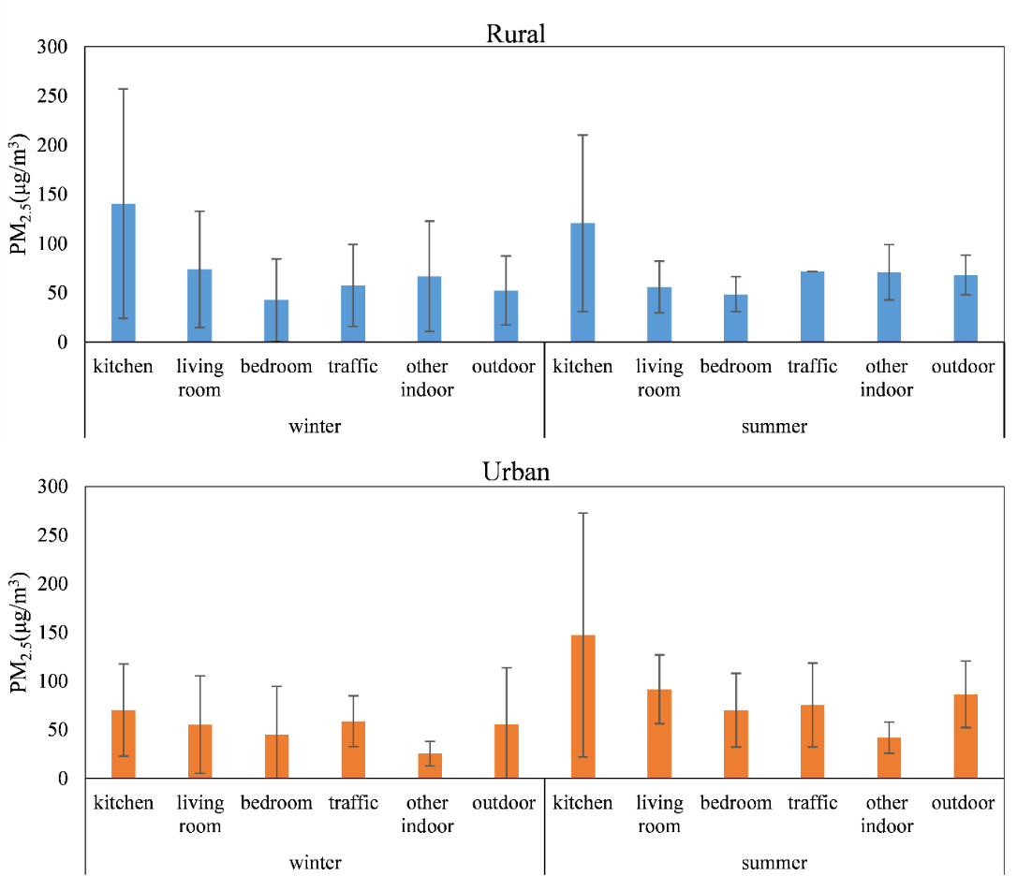
Fig. 6 Average personal exposure levels in different microenvironments in rural and urban areas

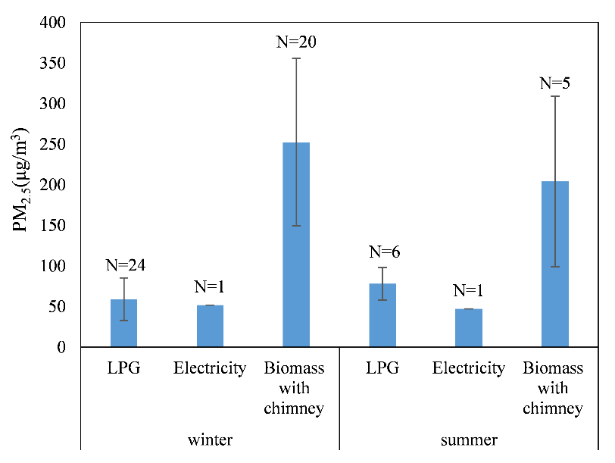
Fig. 7 Average personal exposure levels in kitchens by stove type in rural areas

Time-activity patterns and PM_{2.5} exposure amounts
The average amount of time spent in different microenvironments for all participants according to the time-activity pattern records, is given in Table S6, and the average proportion of time is shown in Figure S7. Rural people spent the majority of their day in indoor microenvironments, 90% (SD 20%) in winter and 86% (SD 20%) in summer. The microenvironment in which they were likely to spend the largest amount of time was the bedroom, about 47% (SD 8%) in winter and 37% (SD 7%) in summer, followed by the living room. Seemingly, rural participants spent more time in their bedrooms when it was cold. Meanwhile, they spent about 11% (SD 5%) of their time in winter and 15% (SD 4%) in summer in the kitchen, the focus of our study, where they cooked and were exposed to the highest concentration of PM_{2.5}.
Comparatively, rural people were likely to spend somewhat less time on outdoor activities (9% [SD 11%] in winter/14% [SD 19%] in summer) than urban people (13% [SD 13%] in winter/18% [SD 17%] in summer), but more time in living rooms (27% [SD 15%] in winter/25% [SD 13%] in summer) than urban people (22% [SD 13%] in winter/22% [SD 15%] in summer), who also spent the majority of their time in indoor microenvironments (86% [SD 21%] in winter/77% [SD 23%] in summer). These results agree with previous studies, for example, urban Italians spent 72% of their time at home and 65% of urban German did (39, 40), and individuals in Hong Kong were found to spend about 86% of a day indoors (58).
The calculation of the average amounts of daily exposure in terms of μg$∙h$/m³ of the rural population is shown in Figure 8 (for details see Table S7; figures were calculated from the data listed in Tables S4 and S6 based on equations (1) and (2)), in which the exposure amount when the participants stayed in different microenvironments is also included. The amount of the total daily exposure of rural participants in this study was 1545μg$∙h$/m³ (SD 795) in winter and 1574μg$∙h$/m³ (SD 591) in summer, which is statistically similar (p>0.500). The indoor microenvironments of kitchen, bedroom, living room, and other indoor space contributed the most to the total exposure in rural areas (92% [SD 50%] in winter/85% [SD 31%] in summer). The most noteworthy is that whereas the time rural people spent in their kitchens was about 11–15% of their total time, the exposure amount in kitchens accounted for 24–27% of their total daily exposure. This shows a high health risk of PM_{2.5} exposure in kitchens and that the PM_{2.5} exposure due to cooking is alarming. As for stove type used, analytic results reveal that the rural daily exposure amount on average for winter and summer of people using biomass fuel was 2037μg∙h/m³ (SD 673), of which kitchens accounted for 40% (SD 23%). This was much higher than the exposure amounts of people using LPG (1290μg∙h/m³ [SD 682]) (p=0.000) and electricity (761μg∙h/m³ [SD 101]) (p=0.000), of which kitchens accounted for 15% (SD 3%) and 20% (SD 11%) of the total, respectively. Consequently, clean fuel use could effectively help reduce the risk of personal exposure to PM_{2.5} in rural areas (59). Many studies show that biogas is also a good option (47).

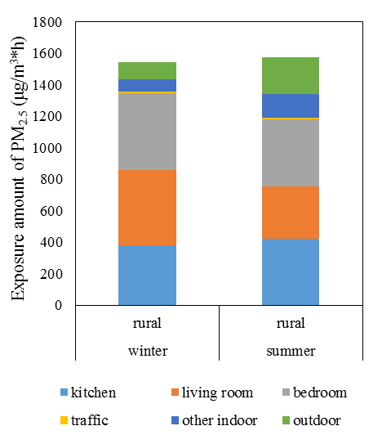
Fig. 8 Daily average personal exposure amounts of rural participants

In urban areas, indoor microenvironments were also the main contributors of the total PM_{2.5} exposure amounts (84% [SD 50%] in winter and 77% [SD 43%] in summer), but the values were somewhat lower than those in rural areas (see Table S7). Due to clean energy use, the exposure amount in urban kitchens was less than in rural kitchens, with 182μg∙h/m³ (SD 145) versus 379μg∙h/m³ (SD 354) (p=0.039) in winter and 325μg∙h/m³ (SD 297) versus 422μg∙h/m³ (SD 338) (p=0.250) in summer.
The results of personal PM_{2.5} exposure in Quzhou in the Yangtze River Delta in the present study underscore the importance of paying attention to the health impact of diverse indoor activities. It is also evident from other studies that serious PM_{2.5} exposure can be attributed to the long periods of time spent in residential and office microenvironments and their higher indoor PM_{2.5} concentrations , which were more highly correlated with personal exposure than outdoor concentrations (42, 50, 60). However, there is some research of urban areas that suggests that outdoor PM_{2.5} levels rather than indoor levels should be used as the measure for personal exposure to PM_{2.5} (35). It must be considered that, in the case where there are few or no sources of indoor air pollution (whether from cooking, heating, or smoking), the average exposure may be represented by the outdoor concentration if the penetration ratio is high (close to one). If, however, there are major indoor sources of air pollution, these may add substantially to the total exposure level (61).
Apparently, the use of portable PM_{2.5} sampling instruments and time-activity pattern records provided substantial details about the sources of PM_{2.5} exposure among rural and urban populations for this article. However, there are some major limitations in our study. The sample size of individual groups was relatively small, and episodic events possibly influenced the results. Thus, the sample sizes need to be increased to gain greater statistical accuracy. Additionally, the recording resolution of the time-activity pattern was set “per hour,” which might have resulted in short-term exposure peaks being lost. We did not carry out a calibration of the PATS+ monitors in indoor environments (where the peak particle concentrations up to thousands of μg/m³ were observed in some traditional kitchens). High PM_{2.5} concentrations can lead to particle deposition, clogging the inner air channel of the sensor, which could result in inaccuracies in the data. Despite this, we expect errors were minimal in our case, as the concentrations were mostly modest during monitoring and the devices were cleaned appropriately according to the protocol after each sampling. In order to identify the main determinants of individual PM_{2.5} exposure among the rural population, more detailed records about individual time-activity patterns and other relevant data (e.g., cooking styles and house ventilation) for the rural population those were not accounted in this article would, however, improve the knowledge regarding PM_{2.5} exposure levels and should be factored into future research.

Conclusion
Based on the measured levels of PM_{2.5} and time-activity pattern records, we analyzed the features of the personal exposure to PM_{2.5} in rural areas in a relatively affluent part of China and compared rural and urban areas in order to narrow the knowledge gap between the levels and sources of personal PM_{2.5} exposure of rural and urban populations. The findings indicate that in rural areas, people were exposed to a daily average PM_{2.5} level of 66μg/m³ in winter and 65μg/m³ in summer. The daily exposure level was higher for those who used biomass for cooking than for those who used LPG or electricity. We also found higher exposure among the elderly and among those who smoked or were exposed to environmental tobacco smoke. Among the different microenvironments, the highest concentration was measured in rural kitchens during cooking, especially where biomass stoves were used. We concluded that indoor microenvironments contributed to the majority (85–92%) of daily personal exposure to PM_{2.5} because people spent more time indoors and there was a higher concentration of PM_{2.5} in indoor microenvironments in rural areas. The use of biomass fuel for cooking was found to be a major source of high levels of exposure in the rural sample population.
Based on our results, we recommend that in order to reduce PM_{2.5} exposure and improve health in rural areas of China, it is necessary to replace biomass and old stoves with clean-fuel stoves, like LPG and electric, and new cooking methods. This transition has started in many villages of China in recent years, but further efforts and policies are needed. Furthermore, the local economy, local practices of cooking and heating, and, not least, possibilities for accessing clean fuel should be taken into consideration when promoting change and effective reduction of PM_{2.5} exposure. In addition, policies to reduce smoking should be encouraged. By combining data on the measured exposure level in microenvironments and time-activity patterns for sub-populations, a comprehensive assessment of levels and sources of exposure should be established for urban and rural areas alike. This would enable further development of more equitable and health-oriented policies.

Acknowledgements
We would like to thank all the participants and field staff of our study. Funding for this research was provided by the National Natural Science Foundation of China (grant 21625701) and the project Airborne: Pollution, Climate Change, and Visions of Sustainability in China funded by the Research Council of Norway and the Center for Advanced Studies, Norway.

References
1. Lim SS, Vos T, Flaxman AD, Danaei G, Shibuya K, Adair-Rohani H, et al. A comparative risk assessment of burden of disease and injury attributable to 67 risk factors and risk factor clusters in 21 regions, 1990–2010: A systematic analysis for the Global Burden of Disease Study 2010. Lancet 2012;380(9859):2224-2260.
2. Steinle S, Reis S, Sabel CE, Semple S, Twigg MM, Braban CF, et al. Personal exposure monitoring of PM_{2.5} in indoor and outdoor microenvironments. Sci Total Environ 2015;508:383-394.
3. Chen YY, Ebenstein A, Greenstone M, Li HB. Evidence on the impact of sustained exposure to air pollution on life expectancy from China's Huai River policy. P Natl Acad Sci USA 2013;110(32):12936-12941.
4. Diaz RV, Dominguez ER. Health risk by inhalation of PM_{2.5} in the metropolitan zone of the City of Mexico. Ecotox Environ Safe 2009;72(3):866-871.
5. Jimenez E, Linares C, Rodriguez LF, Bleda MJ, Diaz J. Short-term impact of particulate matter (PM_{2.5}) on daily mortality among the over-75 age group in Madrid (Spain). Sci Total Environ 2009;407(21):5486-5492.
6. Lai CH, Huang HB, Chang YC, Su TY, Wang YC, Wang GC, et al. Exposure to fine particulate matter causes oxidative and methylated DNA damage in young adults: A longitudinal study. Sci Total Environ 2017;598:289-296.
7. Wei FS, Hu W, Teng EJ, Wu GP, Zhang J. Correlation analysis between air pollution and the prevalence of respiratory diseases of children (Chinese). China Environmental Science 2000;20(3):220-224.
8. Wu R, Dai HC, Geng Y, Xie Y, Masui T, Liu ZQ, et al. Economic impacts from PM_{2.5} pollution-related health effects: A case study in Shanghai. Environ Sci Technol 2017;51(9):5035-5042.
9. Duan XL, Jiang Y, Wang BB, Zhao XG, Shen GF, Cao SZ, et al. Household fuel use for cooking and heating in China: Results from the first Chinese Environmental Exposure-Related Human Activity Patterns Survey (CEERHAPS). Appl Energ 2014;136:692-703.
10. Chen YJ, Tian CG, Feng YL, Zhi GR, Li J, Zhang G. Measurements of emission factors of PM_{2.5}, OC, EC, and BC for household stoves of coal combustion in China. Atmos Environ 2015;109:190-196.
11. Du W, Li XY, Chen YC, Shen GF. Household air pollution and personal exposure to air pollutants in rural China - A review. Environ Pollut 2018;237:625-638.
12. Shen GF, Xue M. Comparison of carbon monoxide and particulate matter emissions from residential burnings of pelletized biofuels and traditional solid fuels. Energ Fuel 2014;28(6):3933-3939.
13. Wei SY, Su YH, Shen GF, Tao S, Min YJ, Wei W. Emission factors of particulate matter and elemental carbon from rural residential wood combustion. Asian J of Ecotoxicology 2013;8(1):29-36.
14. Zhi GR, Chen YJ, Feng YL, Xiong SC, Li J, Zhang G, et al. Emission characteristics of carbonaceous particles from various residential coal-stoves in China. Environ Sci Technol 2008;42(9):3310-3315.
15. Duan X, Wang B, Zhao X, Shen G, Xia Z, Huang N, et al. Personal inhalation exposure to polycyclic aromatic hydrocarbons in urban and rural residents in a typical northern city in China. Indoor Air 2014;24(5):464-473.
16. Baumgartner J, Schauer JJ, Ezzati M, Lu L, Cheng C, Patz J, et al. Patterns and predictors of personal exposure to indoor air pollution from biomass combustion among women and children in rural China. Indoor Air 2011;21(6):479-488.
17. Ni K, Carter E, Schauer JJ, Ezzati M, Zhang YX, Niu HJ, et al. Seasonal variation in outdoor, indoor, and personal air pollution exposures of women using wood stoves in the Tibetan Plateau: Baseline assessment for an energy intervention study. Environ Int 2016;94:449-457.
18. Secrest MH, Schauer JJ, Carter EM, Lai AM, Wang YQ, Shan M, et al. The oxidative potential of PM_{2.5} exposures from indoor and outdoor sources in rural China. Sci Total Environ 2016;571:1477-1489.
19. Zhong JJ, Ding JN, Su YH, Shen GF, Yang YF, Wang C, et al. Carbonaceous particulate matter air pollution and human exposure from indoor biomass burning practices. Environ Eng Sci 2012;29(11):1038-1045.
20. Alnes LWH, Mestl HES, Berger J, Zhang HF, Wang SX, Dong ZQ, et al. Indoor PM and CO concentrations in rural Guizhou, China. Energy Sustain Dev 2014;21:51-59.
21. Blaszczyk E, Rogula-Kozlowska W, Klejnowski K, Kubiesa P, Fulara I, Mielzynska-Svach D. Indoor air quality in urban and rural kindergartens: Short-term studies in Silesia, Poland. Air Qual Atmos Hlth 2017;10(10):1207-1220.
22. Bruce N, Pope D, Rehfuess E, Balakrishnan K, Adair-Rohani H, Dora C. WHO indoor air quality guidelines on household fuel combustion: Strategy implications of new evidence on interventions and exposure-risk functions. Atmos Environ 2015;106:451-457.
23. Canha N, Lage J, Candeias S, Alves C, Almeida SM. Indoor air quality during sleep under different ventilation patterns. Atmos Pollut Res 2017;8(6):1132-1142.
24. Diapouli E, Eleftheriadis K, Karanasiou AA, Vratolis S, Hermansen O, Colbeck I, et al. Indoor and outdoor particle number and mass concentrations in Athens: Sources, sinks and variability of aerosol parameters. Aerosol Air Qual Res 2011;11(6):632-642.
25. Du W, Shen GF, Chen YC, Zhuo SJ, Xu Y, Li XY, et al. Wintertime pollution level, size distribution and personal daily exposure to particulate matters in the northern and southern rural Chinese homes and variation in different household fuels. Environ Pollut 2017;231:497-508.
26. Edwards RD, Li Y, He G, Yin Z, Sinton J, Peabody J, et al. Household CO and PM measured as part of a review of China's National Improved Stove Program. Indoor Air 2007;17(3):189-203.
27. Gu QP, Gao X, Chen Y, Yu Q, Zhang Y, Chen LM. Characteristics of indoor PM_{2.5} concentration in rural areas of Jiangsu Province (Chinese). J of Fudan U (Natural Science) 2009(5):593-597.
28. Hu W, Downward GS, Reiss B, Xu J, Bassig BA, Hosgood HD, et al. Personal and indoor PM_{2.5} exposure from burning solid fuels in vented and unvented stoves in a rural region of China with a high incidence of lung cancer. Environ Sci Technol 2014;48(15):8456-8464.
29. Kurmi OP, Semple S, Steiner M, Henderson GD, Ayres JG. Particulate matter exposure during domestic work in Nepal. Ann Occup Hyg 2008;52(6):509-517.
30. Ma LY, Dong ZQ, Wu KJ, Pan J. Indoor air quality and characteristics of fine particle for rural Guizhou. Env Monitoring in China 2015;31(1):28-34.
31. Pokhrel AK, Bates MN, Acharya J, Valentiner-Branth P, Chandyo RK, Shrestha PS, et al. PM_{2.5} in household kitchens of Bhaktapur, Nepal, using four different cooking fuels. Atmos Environ 2015;113:159-168.
32. Zhao YJ, Zhao B. Emissions of air pollutants from Chinese cooking: A literature review. Build Simul-China 2018;11(5):977-995.
33. Wang Q, Xu DQ. Characteristics of PM_{2.5} pollution in rural residential environment (Chinese). China Environ Hlth 2007;10:51-53.
34. Zhou ZF, Liu K, Sun YL. Elements composition characteristics and sources of atmospheric PM_{2.5} in rural areas south of Jiangsu (Chinese). Research of Environ Sc 2006;19(3):24-28.
35. Han JB, Ni TR, Li PH, Han B, Bai ZP. Exposure of elderly to PM_{2.5} in Tianjin (Chinese). China Environ Sc 2015;35(2):610-616.
36. Kumar R, Goel N, Gupta N, Singh K, Nagar S, Mittal J. Indoor air pollution and respiratory illness in children from rural India: Apilot study. Indian J of Chest Diseases & Allied Sc 2014;56(2):79-83.
37. Brauer M, Amann M, Burnett RT, Cohen A, Dentener F, Ezzati M, et al. Exposure assessment for estimation of the global burden of disease attributable to outdoor air pollution. Environ Sci Technol 2012;46(2):652-660.
38. Chafe ZA, Brauer M, Klimont Z, van Dingenen R, Mehta S, Rao S, et al. Household cooking with solid fuels contributes to ambient PM_{2.5} air pollution and the burden of disease. Environ Health Persp 2014;122(12):1314-1320.
39. Brasche S, Bischof W. Daily time spent indoors in German homes: Baseline data for the assessment of indoor exposure of German occupants. Int J Hyg Envir Heal 2005;208(4):247-253.
40. Buonanno G, Stabile L, Morawska L. Personal exposure to ultrafine particles: The influence of time-activity patterns. Sci Total Environ 2014;468:903-907.
41. Shao ZJ, Bi J, Ma ZW, Wang JN. Seasonal trends of indoor fine particulate matter and its determinants in urban residences in Nanjing, China. Build Environ 2017;125:319-325.
42. Van Ryswyk K, Wheeler AJ, Wallace L, Kearney J, You HY, Kulka R, et al. Impact of microenvironments and personal activities on personal PM_{2.5} exposures among asthmatic children. J Expo Sci Env Epid 2014;24(3):260-268.
43. Hu GP, Zhou YM, Tian J, Yao WM, Li JG, Li B, et al. Risk of COPD from exposure to biomass smoke: A metaanalysis. Chest 2010;138(1):20-31.
44. Yu K, Qiu GK, Chan KH, Lam KBH, Kurmi OP, Bennett DA, et al. Association of solid fuel use with risk of cardiovascular and all-cause mortality in rural China. Jama-J Am Med Assoc 2018;319(13):1351-1361.
45. Zhang J. Indoor air quality and its adverse health effects in rural China. Epidemiology 2007;18(5):S75-S76.
46. Yan WQ, Zhang XY, Lang FL, Cao J. Individual exposure to atmospheric fine particles in the Beijing area (Chinese). China Environ Sc 2014;34(3):774-779.
47. Wang SX, Wei W, Li D, Aunan K, Hao JM. Air pollutants in rural homes in Guizhou, China: Concentrations, speciation, and size distribution. Atmos Environ 2010;44(36):4575-4581.
48. Gulliver J, Briggs DJ. Personal exposure to particulate air pollution in transport microenvironments. Atmos Environ 2004;38(1):1-8.
49. Lei XN, Xiu GL, Li B, Zhang K, Zhao MF. Individual exposure of graduate students to PM_{2.5} and black carbon in Shanghai, China. Environ Sci Pollut R 2016;23(12):12120-12127.
50. Lim CY, Guak SY, Lee KY, Hong YC. Time-activity patterns and PM_{2.5} exposure of the elderly in urban and rural areas (Korean). J of Environ Hlth Sc 2016;42(1):1-9.
51. Airborne: Pollution, climate change, and visions of sustainability in China. https://www.hf.uio.no/ikos/english/research/projects/airborne-pollution-china/index.html Accessed December 20, 2018
52. Hansen MH, Liu ZH. Air pollution and grassroots echoes of “ecological civilization” in rural China. The China Quarterly 2018;234:320-339.
53. Particle and temperature sensor (PATS+). http://berkeleyair.com/monitoring-instruments-sales-rentals/particle-and-temperature-sensor-pats/ Accessed December 20, 2018
54. Yuan ZK, He XZ. Aging population and health inequalities in the rural areas of China. J Am Geriatr Soc 2010;58(6):1210-1211.
55. Pope D, Bruce N, Dherani M, Jagoe K, Rehfuess E. Real-life effectiveness of "improved" stoves and clean fuels in reducing PM_{2.5} and CO: Systematic review and meta-analysis. Environ Int 2017;101:7-18.
56. Huang Y, Du W, Chen YC, Shen GF, Su S, Lin N, et al. Household air pollution and personal inhalation exposure to particles (TSP/PM_{2.5}/PM_{1.0}/PM_{0.25}) in rural Shanxi, North China. Environ Pollut 2017;231:635-643.
57. Pant P, Habib G, Marshall JD, Peltier RE. PM_{2.5} exposure in highly polluted cities: A case study from New Delhi, India. Environ Res 2017;156:167-174.
58. Chau CK, Tu EY, Chan DWT, Burnett CJ. Estimating the total exposure to air pollutants for different population age groups in Hong Kong. Environ Int 2002;27(8):617-630.
59. Shen GF. Quantification of emission reduction potentials of primary air pollutants from residential solid fuel combustion by adopting cleaner fuels in China. J Environ Sci-China 2015;37:1-7.
60. Ryan PH, Brokamp C, Fan ZH, Rao MB. Analysis of personal and home characteristics associated with the elemental composition of PM_{2.5} in indoor, outdoor and personal air in the RIOPA study. Research Report 2015;185:3-40.
61. Aunan K, Ma Q, Lund MT, Wang SX. Population-weighted exposure to PM_{2.5} pollution in China: An integrated approach. Environ Int 2018;120:111-120.

